Water System Name:
2018 Consumer Confidence Report
California Pines Community Services District Report Date: 05/31/2019

We test the drinking water quality for many constituents as required by state and federal regulations. This report shows the results of our monitoring for the period of January 1 to December 31, 2018 and may include earlier monitoring data.

Este informe contiene informacion muy importante sobre su agua para beber. Favor de comunicarse California Pines Community Services District 530.233.2766
Type of water source(s) in use: Groundwater
Name & general location of source(s):Viceroy Well #4, Well #5 Located at our District Office Site

Drinking Water Source Assessment information: Contact: Division of Drinking Water 530.224.4800

Time and place of regularly scheduled board meetings for public participation: Cal Pines CSD District Office
4:00 PM on the 3rd Wednesday of every month, 376 CO RD 71 Alturas CA 96101 For more information, contact: Holly Sherer Phone: ( 530 )233.2766

TERMS USED IN THIS REPORT

Maximum Contaminant Level (MCL): The highest level of a contaminant that is allowed in drinking water . Primary MCLs are set as close to the PHGs (or MCLGs) as is economically and technologically feasible. Secondary MCLs are set to protect the odor, taste, and appearance of drinking water.
Maximum Contaminant Level Goal (MCLG): The level of a contaminant in drinking water below which there is no known or expected risk to health. MCLGs are set by the U.S. Environmental Protection Agency (U.S. EPA).
Public Health Goal (PHG): The level of a contaminant in drinking water below which there is no known or expected risk to health. PHGs are set by the California Environmental Protection Agency.
Maximum Residual Disinfectant Level (MRDL): The highest level of a disinfectant allowed in drinking water. There is convincing evidence that addition of a disinfectant is necessary for control of microbial contaminants.
Maximum Residual Disinfectant Level Goal (MRDLG): The level of a drinking water disinfectant below which there is no known or expected risk to health. MRDLGs do not reflect the benefits of the use of disinfectants to control microbial contaminants.
Primary Drinking Water Standards (PDWS): MCLs and MRDLs for contaminants that affect health along with their monitoring and reporting requirements, and water treatment requirements.
Secondary Drinking Water Standards (SOWS): MCLs for contaminants that affect taste, odor, or appearance of the drinking water. Contaminants with SDWSs do not affect the health at the MCL levels.
Treatment Technique (TT): A required process intended to reduce the level of a contaminant in drinking water.
Regulatory Action Level (AL): The concentration of a contaminant which, if exceeded, triggers treatment or other requirements that a water system must follow.
Variances and Exemptions: Permissions from the State Water Resources Control Board (State Board) to exceed an MCL or not comply with a treatment technique under certain conditions.
Level 1 Assessment: A Level 1 assessment is a study of the water system to identify potential problems and determine (if possible) why total coliform bacteria have been found in our water system.
Level 2 Assessment: A Level 2 assessment is a very detailed study of the water system to identify potential problems and determine (if possible) why an E. coli MCL violation has occurred and/or why total coliform bacteria have been found in our water system on multiple occasions.
ND: not detectable at testing limit
ppm: parts per million or milligrams per liter (mg/L) ppb: parts per billion or micrograms per liter (µg/L) ppt: parts per trillion or nanograms per liter (ng/L) ppq: parts per quadrillion or picogram per liter (pg/L) pCi/L: picocuries per liter (a measure ofradiation)

SWSCCRForm Revised February 2019

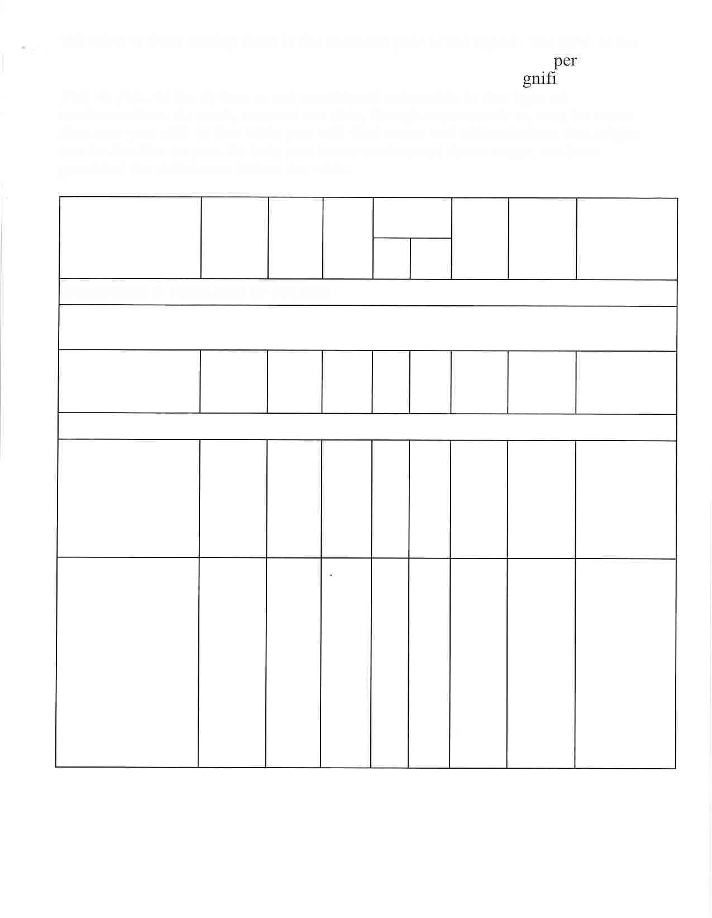
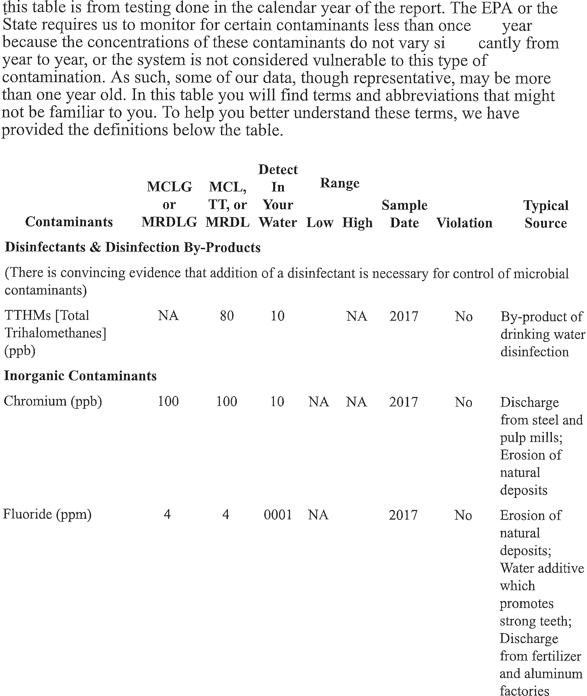

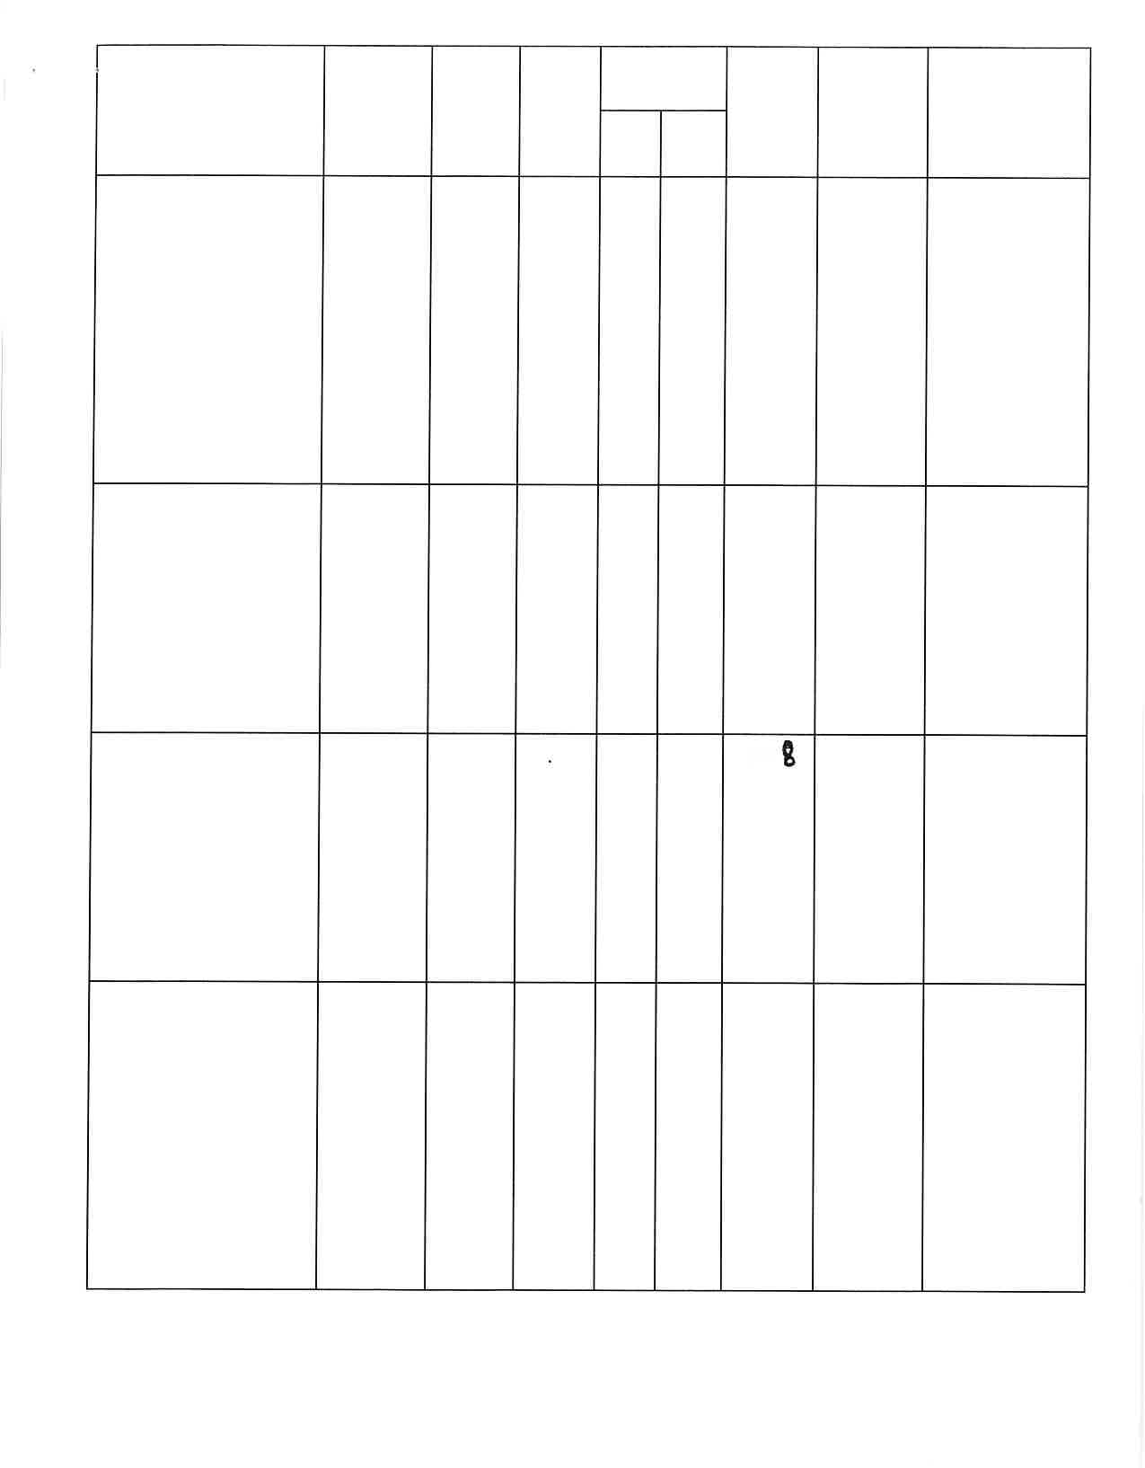
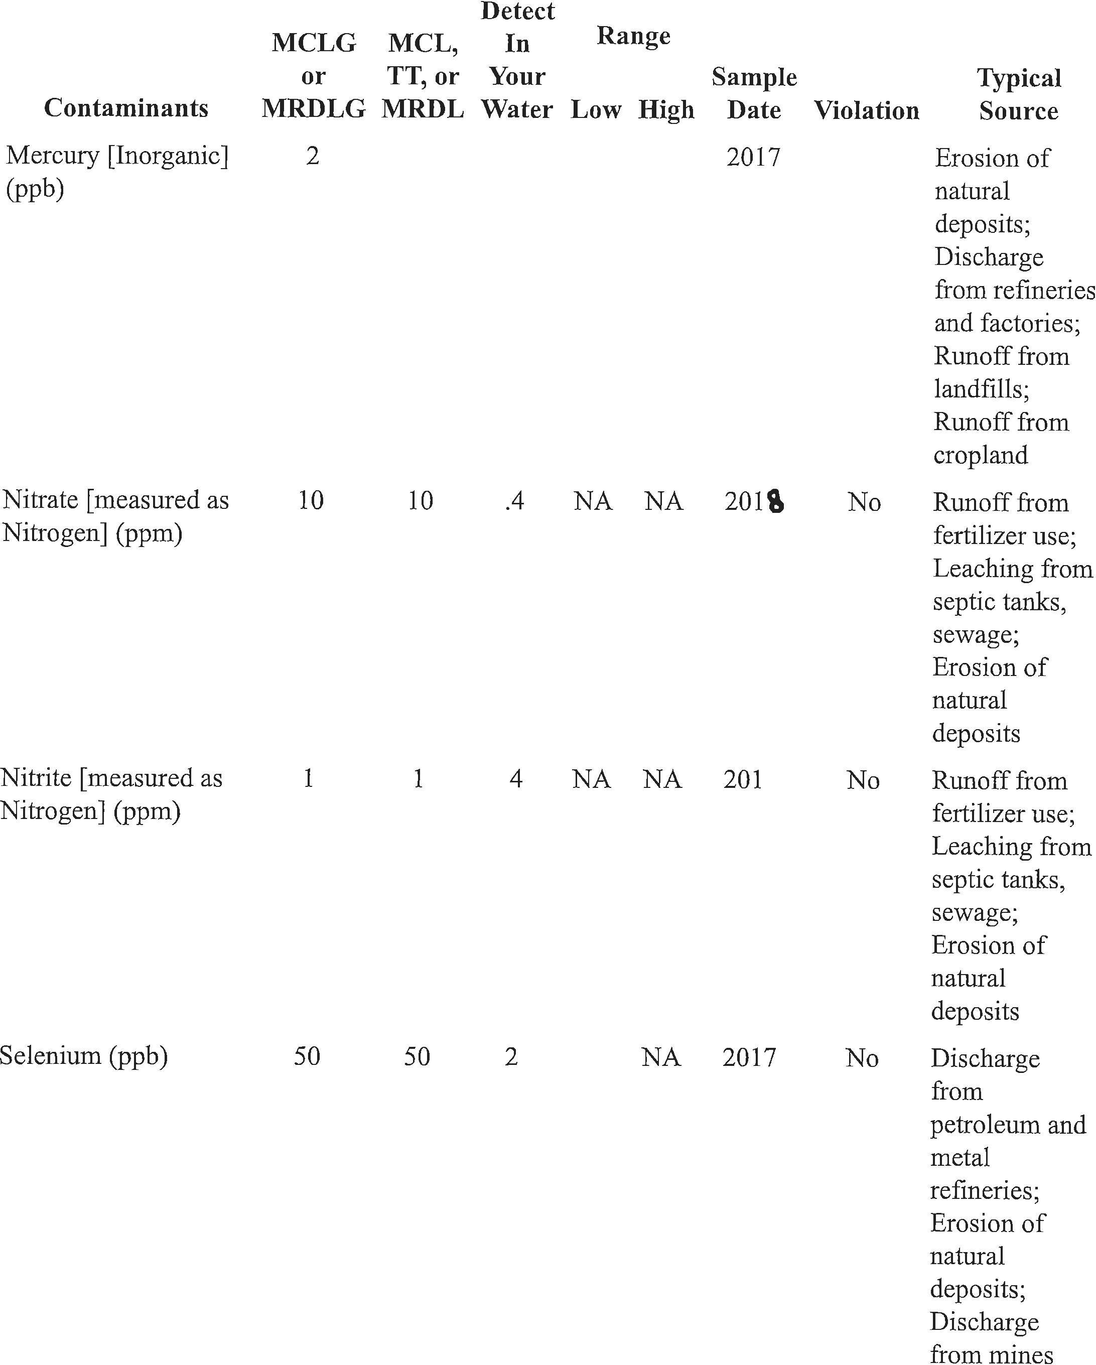
2018

