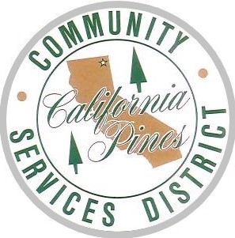
California Pines Community Service District

376 County Road 71/ HC4 Box 43002
Alturas, CA 96101
Ph: 530-233-2766 Fax: 530-233-2704
Employer Identification #: 94-2195606
cpcsd.specialdistrict.org

Board Meeting Minutes
  - February 19th, 2025
11:00 AM
Buck Rodgers, chairman of the board of directors, called the meeting to order at 11:00 a.m.

ROLL CALL: 11:00
Board Members | Staff Present | Public Present
Buck Rodgers – Chairman | Justin Ulrich | Mark Bishop
Skip Kelly – Vice Chairman | Ryan Sherer
Terry Kelly – Director | Alan Botello
Louise Waldron – Secretary

ANNOUNCEMENTS, INTRODUCTIONS, RECOGNITIONS:
none

PUBLIC COMMENT:
none

SCHEDULED ITEMS:
none

CONSENT CALENDER: 11:02
(All matters under the Consent Calendar are routine and will be approved by one motion unless a board member requests separate action on a specific item.)
- Minutes – January 2025
- December 2024: Balance – Profit and Loss – Previous Year Comparison

Motion:
Skip Kelly moved to approve all items on the consent calendar, seconded by Terry Kelly and carried unanimously.

OLD BUSINESS: 11:05
- Election 2025
    - Review of argument in favor of Measure M
    - Review of argument in favor of Measure N
    - Updates on election processes and decisions.
- Offer Received for Retired Vehicle that did not sell at auction, board accepted offer.

NEW BUSINESS: 11:11

- Resolution 2025-C: lot mow, approved and adopted
  - Motion: Skip Kelly moved to approve all policy changes. Seconded by Terry Kelly, the motion carried unanimously.
AYES: 3 NOES: 0 ABSENT: 0

GENERAL MANAGERS’ REPORT: 11:14
- Acknowledgment of flooding issues within CalPines; the district is actively performing drain maintenance.
- Leak Fixes continue
- Electrical project and repairs to CSD Yard.
- Seasonal Firefighters are being recruited for the 2025 fire season
- Comparison of Graders needed; existing equipment may not be efficient or effective enough for the road maintenance required each year.
MEETING ADJOURNED: 11:34

Motion:
Terry Kelly moved to adjourn the regular meeting. Second, Skip Kelly, the motion carried unanimously.
Certificate of Posting:
I, Louise Waldron – Secretary to the Board of Directors of the California Pines Service District, hereby certify, to the best of my knowledge, that this is a true excerpt of the minutes of the February 19th, 2025, Meeting of the Board of the California Pines Community Service District.

The next regular meeting of the Board of Directors will be on March 19th, 2025, at 11:00 am.

