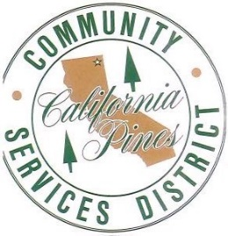
CALIFORNIA PINES COMMUNITY SERVICES DISTRICT
HC 4 BOX 43002 / County Road 71 Building 376
ALTURAS, CALIFORNIA 96101
PHONE: 530-233-2766 FAX: 530-233-2704
cpcsd.specialdistrict.org

SPECIAL MEETING AGENDA

June 30th, 2022
4:00 P.M.

Assistance for the Disabled: If you are disabled and need accommodation to participate in the meeting, please call 530-233-2766 to make necessary arrangements.

DUE TO COVID-19, WE REQUEST THAT THOSE WISHING TO PARTICIPATE IN THE MEETING JOIN VIA ZOOM. A ZOOM LINK WILL BE POSTED ON THE DISTRICT’S WEBSITE.

CALL TO ORDER

1. Roll Call

PUBLIC COMMENT: Any member of the public may address the Board now on any matter on this agenda. The Board requests that members of the public limit their comments to a maximum of three minutes. (PLEASE NOTE THAT NOTHING UNDER THIS SECTION MAY BE ACTED UPON IN THIS MEETING.)

- Open received bids for equipment sales.

ADJOURNEMENT

CERTIFICATE OF POSTING

I, Bailey Randall, Secretary to the Board of Directors of the California Pines Community Services District, hereby certify that on June 30th, 2023, I posted a copy of the foregoing agenda near the regular meeting place of the Board of Directors of the California Pines Community Services District, said time being at least 24 hours in advance of the meeting.

Bailey Randall
Secretary to the Board

