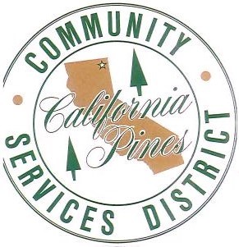
Contact California Pines CSD  Telephone (530)233-2766  Address County Rd 71 #376  Email calpinescsd@frontiernet.net  Website Cpcsd.specialdistrict.org | FOR IMMEDIATE RELEASE  September 7, 2017

NOTICE OF PUBLIC HEARING

Hearing on Proposed Final Budget of California Pines Community Services District

For Fiscal Year 2017/18
NOTICE IS HEREBY GIVEN that the California Pines Community Service District has scheduled a public hearing to be held on September 19, 2017 at 4:00 P.M. at the District Office, County Road 71 #376, Alturas, CA for consideration of the proposed Final Budget. Any person may appear at the time of the hearing and be heard regarding any item on the proposed Final Budget
If you have any questions, please contact California Pines CSD at (530)233-2766 or email at calpinescsd@frontiernet.net.

