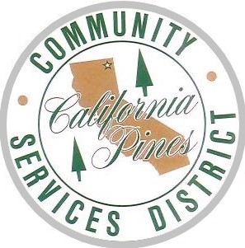
California Pines
  - COMMUNITY SERVICES DISTRICT
376 County Road 71
Alturas, California 96101
Phone: (530) 233-2766
calpinescsd@frontiernet.net

Board Questionnaire

Name: ____________________________________________________________________________
Residence Address: __________________________________________________________________
Mailing Address: ____________________________________________________________________
Occupation: ________________________________________________________________________
Phone Number: Home: ________________ Business:________________ Cell:_________________
E-Mail Address: _____________________________________________________________________

- How long have you lived in California Pines/Alturas? _____________________________
- Are you a registered voter in Alturas? ☐YES ☐ NO
- Why are you seeking a position on the Board? __________________________________ ________________________________________________________________________________________________________________________________________________
- What is your experience or knowledge regarding the Board or California Pines? _______
________________________________________________________________________________________________________________________________________________
- State your views regarding the work of the Board._______________________________
________________________________________________________________________________________________________________________________________________
- The board meets a minimum of 12 times a year; more if there are special meetings or projects. Therefore, it is required for all members to be in attendance to ensure a quorum. Are you able to devote this amount of time? ☐ YES ☐ NO
- The Board meets on the 3rd Wednesday of each month during business hours. Are you able to attend meetings on weekdays? ☐ YES ☐ NO
- Community members are encouraged to attend board meetings. Have you attended any Board meetings? ☐ YES ☐ NO
If yes, how many meetings have you attended in the last 12 months? _______________
- Would there be a conflict of interest if you were appointed to this Board?
☐ YES ☐ NO
If yes, please explain:______________________________________________________
________________________________________________________________________
- Have you ever come before or dealt with the Board? ☐ YES ☐ NO
If yes, please explain:______________________________________________________
________________________________________________________________________
- Have you ever served on a local government Board or Committee in this or any other community? ☐ YES ☐ NO
If yes, please explain:______________________________________________________
________________________________________________________________________
________________________________________________________________________
If additional space is needed, please continue on a separate sheet of paper.
Return to: Office Administrator or Board Secretary, California Pines Community District Office, 376 CO. RD. 71, Alturas, CA 96101. Please include a cover letter expressing your interest in serving on the board of directors.
Please call or email if you have any questions. (530) 233-2766 - calpinescsd@frontiernet.net

